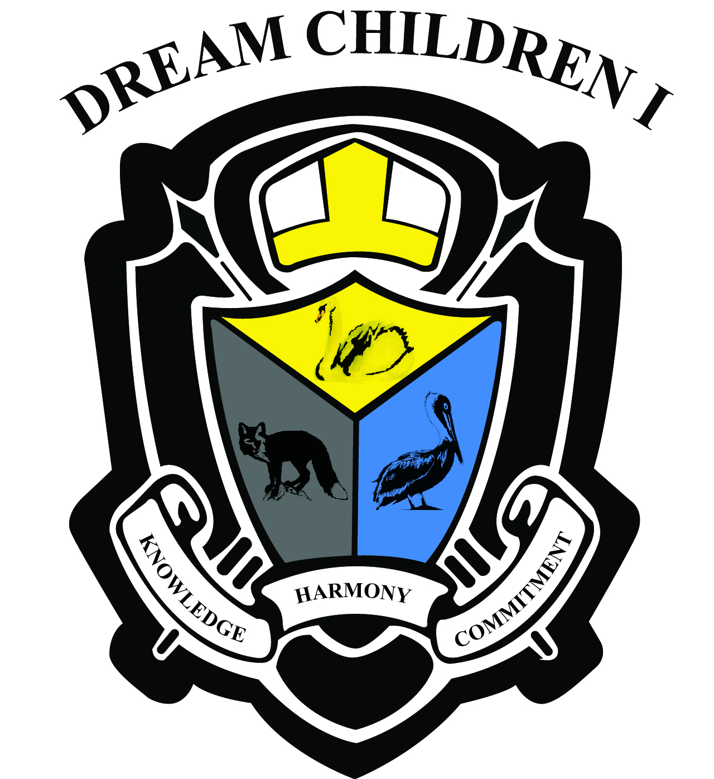
Dream Children, Inc. Together with Knowledge Is Power Early Learning Programs
Annual Enrollment
INTENT FORM

As the new school year is approaching, we would like to know your intentions. If you plan to continue enrollment in our programs (Infant/Toddler, Pre-K, Non Public Education or Afterschool) please indicate your intentions below and return no later than August 1, _______.
--------------------------------------------------------------------------------------

Child(ren) Name:
_________________________________________________________
_________________________________________________________
Check appropriate box:

□ I Plan to return Fall _____
□ I Do Not Plan to return Fall _____

Program of Interest (inquire for one to one Conversation or appointment 704 506 6053, 704 394 8052 or dreamchildren2915@gmail.com)

∆ Infant Toddler
∆ PreK
∆ Non Public School – Grades (K-6)
∆ Before or After School

Center Name:
□ Dream Children, Inc
□ Knowledge Is Power

_________________-______ ________________-_______
Parent Signature Date Director Signature Date

